CPE301 – SPRING 2019

Design Assignment 2B TASK2

Student Name: yeeunLee

Student #:2001614222

Student Email: leey81@nevada.unlv.com

Primary Github address: https://github.com/yeeun219/submission_da.git

Directory: cpe301\DesignAssignments\DA2B\T2

1. **COMPONENTS LIST AND CONNECTION BLOCK DIAGRAM w/ PINS**

while (1) //Repeat continuously,blinking LED

*_delay_ms*(435);//Create a Delay of 60%DC

*_delay_ms*(290);//Create a Delay of 40%DC

*_delay_ms*(1250);: //Create a Delay of 1.25s

ISR (INT0_vect)//ISR for external interrupt 0

1. **DEVELOPED CODE OF TASK 2**

/*

* GccApplication1.c

*

* Created: 2019-03-04 오후 5:28:14

* Author : llje2

*/

#define *F_CPU* 16000000UL

#include <avr/io.h>

#include <util/delay.h>

#include <avr/interrupt.h>

int main(void)

{

//turn led off

DDRB |=(1<<5);

PORTB |=(1<<5);

DDRB |=(1<<2);

PORTB |=(1<<2); //TURN LED OFF

//SET PORTC.2 FOR INPUT

DDRC &=(0<<2);

PORTC |= (1<<2);

EICRA = 0x2;//make INT0 falling edge triggered

EIMSK = (1<<INT0);//enable external interrupt 0

sei ();//enable interrupts

while (1) //Repeat continuously

{

PORTB &= ~(1<<2); //turn on

*_delay_ms*(435); //0.435SEC DELAY (60%DC)

PORTB |=(1<<2); //TURN LED OFF

*_delay_ms*(290); //0.29SEC DELAY (40%DC)

}

return 0;

}

ISR (INT0_vect)//ISR for external interrupt 0

{

PORTB &= ~(1<<2); //TURN LED ON

*_delay_ms*(1250); // DELAY 1.25sec

}

1. **SCHEMATICS**

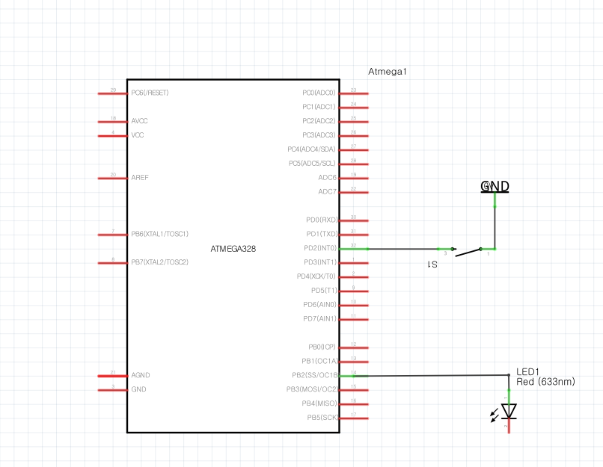

1. **SCREENSHOTS OF EACH TASK OUTPUT (ATMEL STUDIO OUTPUT)**

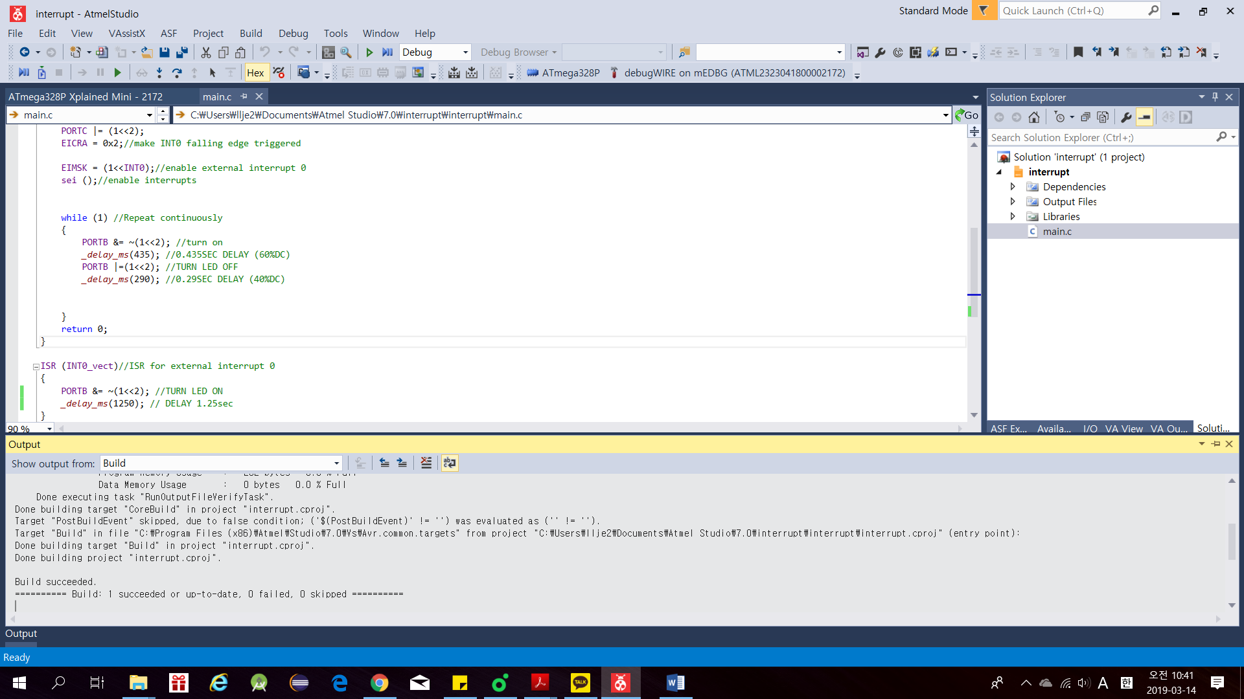

1. **SCREENSHOT OF EACH DEMO (BOARD SETUP)**

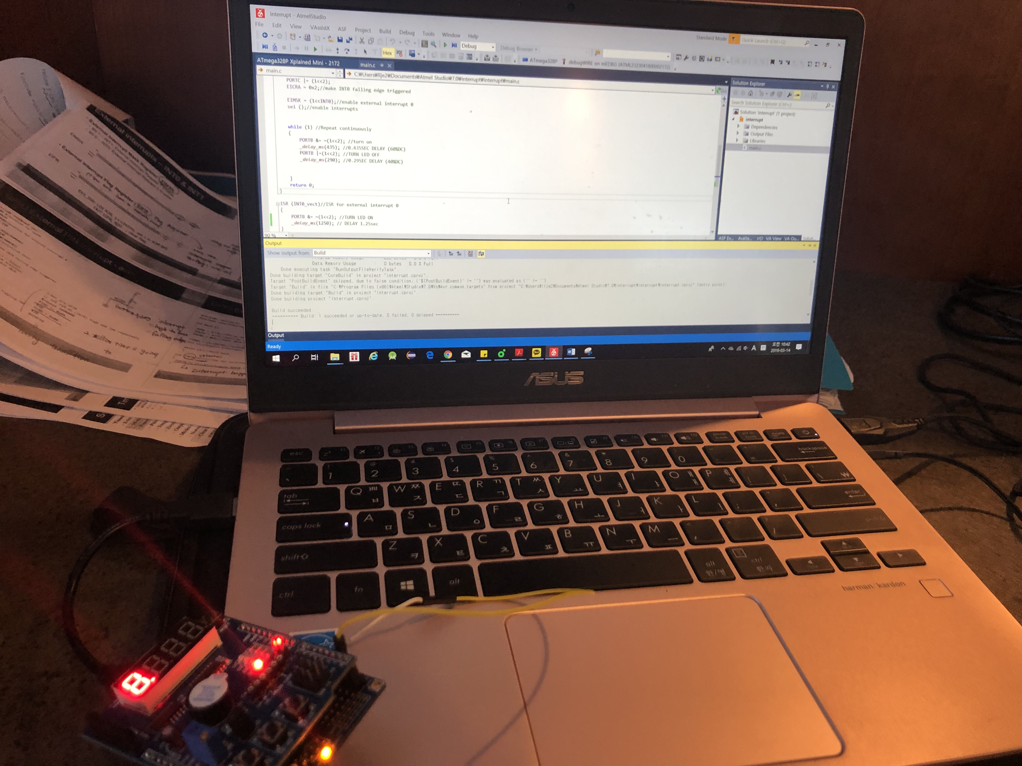

1. **VIDEO LINKS OF EACH DEMO**

https://www.youtube.com/watch?v=cqjJ4OXZ5G0&feature=share

1. **GITHUB LINK OF THIS DA**

Primary Github address: https://github.com/yeeun219/submission_da.git

Directory: cpe301\DesignAssignments\DA2A\T2

**Student Academic Misconduct Policy**

<http://studentconduct.unlv.edu/misconduct/policy.html>

“This assignment submission is my own, original work”.

YEEUNLEE